**JOE SHARON J  
727722EUEE047**

**WEEK 3 SPRING/MAVEN EXCERCISES**

**Exercise 1: Configuring a Basic Spring Application**

**Scenario:**

Your company is developing a web application for managing a library. You need to use the Spring Framework to handle the backend operations.

**Steps:**

1. **Set Up a Spring Project:**
   * Create a Maven project named **LibraryManagement**.
   * Add Spring Core dependencies in the **pom.xml** file.
2. **Configure the Application Context:**
   * Create an XML configuration file named **applicationContext.xml** in the **src/main/resources** directory.
   * Define beans for **BookService** and **BookRepository** in the XML file.
3. **Define Service and Repository Classes:**
   * Create a package **com.library.service** and add a class **BookService**.
   * Create a package **com.library.repository** and add a class **BookRepository**.
4. **Run the Application:**
   * Create a main class to load the Spring context and test the configuration.

**CODE**

import org.springframework.context.ApplicationContext;

import org.springframework.context.support.ClassPathXmlApplicationContext;

public class MainApp {

public static void main(String[] args) {

ApplicationContext context = new ClassPathXmlApplicationContext("applicationContext.xml");

BookService bookService = context.getBean("bookService", BookService.class);

bookService.addBook("Spring in Action");

}

public static class BookRepository {

public void saveBook(String title) {

System.out.println("Book saved: " + title);

}

}

public static class BookService {

private BookRepository bookRepository;

public void setBookRepository(BookRepository bookRepository) {

this.bookRepository = bookRepository;

}

public void addBook(String title) {

System.out.println("Adding book: " + title);

bookRepository.saveBook(title);

}

}

}

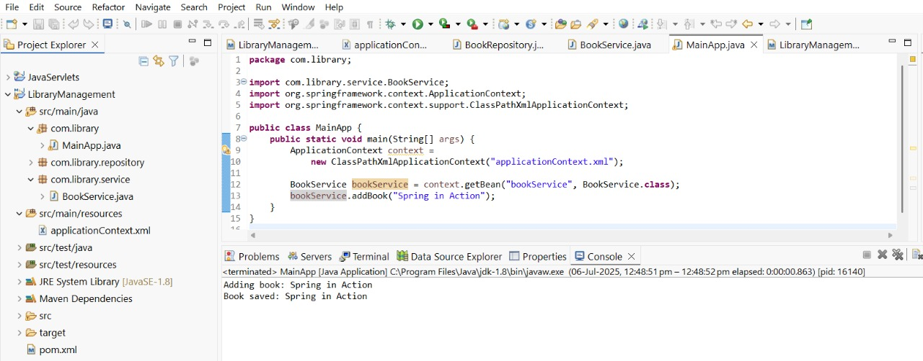

**Exercise 2: Implementing Dependency Injection**

**Scenario:**

In the library management application, you need to manage the dependencies between the BookService and BookRepository classes using Spring's IoC and DI.

**Steps:**

1. **Modify the XML Configuration:**
   * Update **applicationContext.xml** to wire **BookRepository** into **BookService**.
2. **Update the BookService Class:**
   * Ensure that **BookService** class has a setter method for **BookRepository**.
3. **Test the Configuration:**
   * Run the **LibraryManagementApplication** main class to verify the dependency injection.

**CODE:**

import org.springframework.context.ApplicationContext;

import org.springframework.context.support.ClassPathXmlApplicationContext;

public class MainApp {

public static void main(String[] args) {

ApplicationContext context = new ClassPathXmlApplicationContext("applicationContext.xml");

BookService bookService = context.getBean("bookService", BookService.class);

bookService.addBook("Effective Java");

}

public static class BookRepository {

public void saveBook(String title) {

System.out.println("Book saved: " + title);

}

}

public static class BookService {

private BookRepository bookRepository;

public void setBookRepository(BookRepository bookRepository) {

this.bookRepository = bookRepository;

}

public void addBook(String title) {

System.out.println("Adding book: " + title);

bookRepository.saveBook(title);

}

}

}

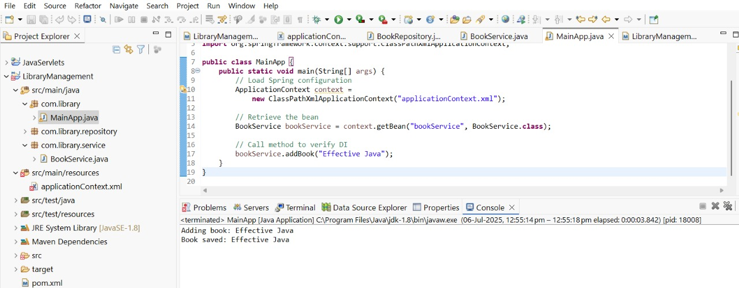

**Exercise 4: Creating and Configuring a Maven Project**

**Scenario:**

You need to set up a new Maven project for the library management application and add Spring dependencies.

**Steps:**

1. **Create a New Maven Project:**
   * Create a new Maven project named **LibraryManagement**.
2. **Add Spring Dependencies in pom.xml:**
   * Include dependencies for Spring Context, Spring AOP, and Spring WebMVC.
3. **Configure Maven Plugins:**
   * Configure the Maven Compiler Plugin for Java version 1.8 in the pom.xml file.

**CODE:**

import org.springframework.context.ApplicationContext;

import org.springframework.context.support.ClassPathXmlApplicationContext;

public class MainApp {

public static void main(String[] args) {

ApplicationContext context = new ClassPathXmlApplicationContext("applicationContext.xml");

BookService bookService = context.getBean("bookService", BookService.class);

bookService.addBook("Clean Code: A Handbook of Agile Software Craftsmanship");

}

public static class BookRepository {

public void saveBook(String title) {

System.out.println("Repository: Successfully stored book -> " + title);

}

}

public static class BookService {

private BookRepository bookRepository;

public void setBookRepository(BookRepository bookRepository) {

this.bookRepository = bookRepository;

}

public void addBook(String title) {

System.out.println("Service: Processing new book addition -> " + title);

bookRepository.saveBook(title);

}

}

}

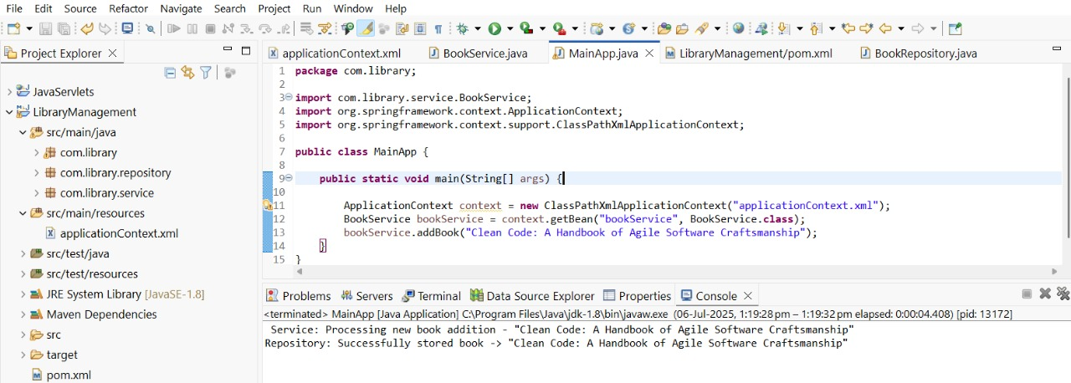

**Spring Data JPA - Quick Example**

**CODE:**

package com.cognizant.ormlearn.model;

import javax.persistence.Column;

import javax.persistence.Entity;

import javax.persistence.Id;

import javax.persistence.Table;

@Entity

@Table(name = "country")

public class Country {

@Id

@Column(name = "co_code")

private String code;

@Column(name = "co_name")

private String name;

public Country() {

}

public String getCode() {

return code;

}

public void setCode(String code) {

this.code = code;

}

public String getName() {

return name;

}

public void setName(String name) {

this.name = name;

}

@Override

public String toString() {

return "Country [code=" + code + ", name=" + name + "]";

}

}

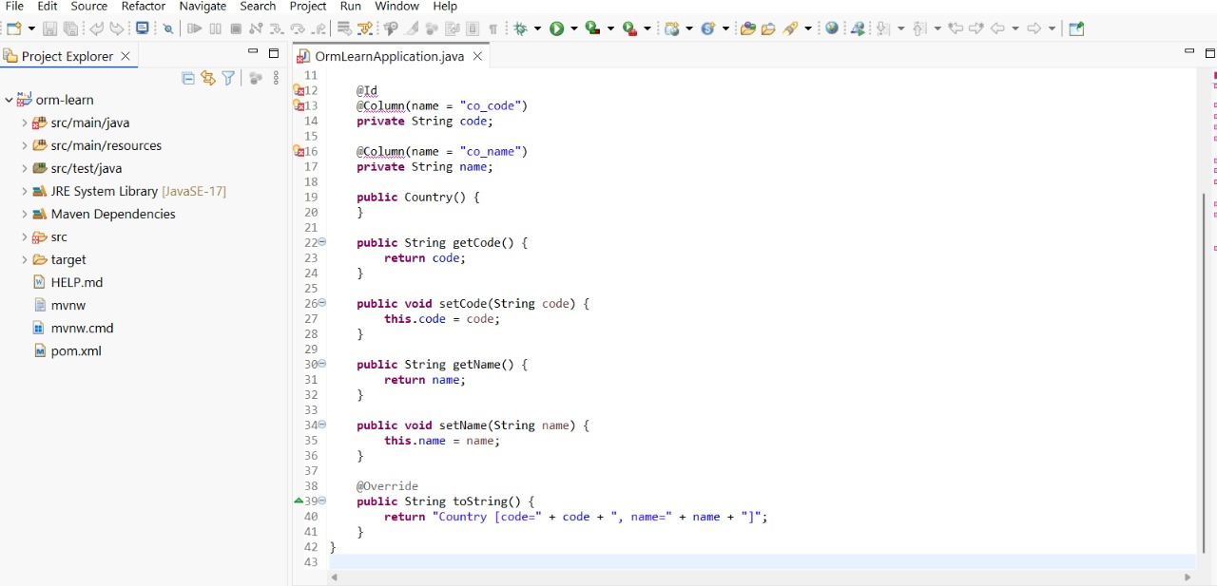

**Difference between JPA, Hibernate and Spring Data JPA**

**Code**

// HibernateUtil to get SessionFactory

public class HibernateUtil {

private static final SessionFactory sessionFactory;

static {

try {

sessionFactory = new Configuration()

.configure("hibernate.cfg.xml")

.buildSessionFactory();

} catch (Throwable ex) {

throw new ExceptionInInitializerError(ex);

}

}

public static SessionFactory getSessionFactory() {

return sessionFactory;

}

}

